Scoil Mhuire, Kilvemnon 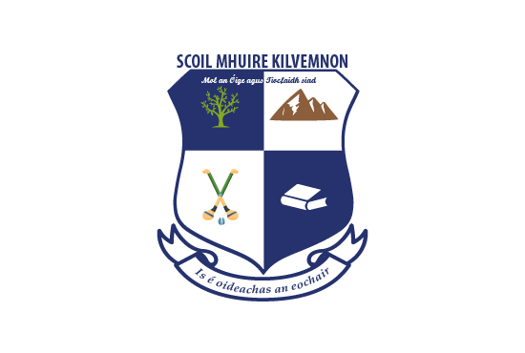Mullinahone, Thurles, Co. Tipperary Email:principalkilvemnon@gmail.com Web: www.scoilmhuirekilvemnon.ie
Telephone: 052 9153542 Registered Charity No: 20205138 Roll No. 18459C
Príomhoide: Catherine Noonan Leas Phríomhoide: Clodagh Barry

Scoil Mhuire Kilvemnon Wellbeing Policy 2024/25 - SSE

Rationale

Schools and centres for education in Ireland play a vital role in the promotion of wellbeing through a range of activities and approaches to support the academic, physical, mental, emotional, social and spiritual development of all children and young people. (Wellbeing Framework for Practice 2019)
Scoil Mhuire Kilvemnon seeks to promote and support all aspects of the children’s wellbeing as a core value of our ethos. We strive to ensure that all our students can flourish in an environment that is nurturing, supportive and progressive. We aim to ensure that each child, through confidence and self-belief may achieve their full potential and we believe that this can be achieved when wellbeing is present. Our understanding of wellbeing is in keeping with the World Health Organisation definition of wellbeing being present “when a person realises their potential, is resilient in dealing with the normal stresses of their life, takes care of their physical wellbeing and has a sense of purpose, connection and belonging to a wider community. It is a fluid way of being and needs nurturing throughout life.” (WHO, 2001)

In the school environment, social and emotional skills do not exist in isolation but interact with cognitive skills development. The role of the school is now understood as a place which develops the ‘whole child’, who should leave school with a balanced set of cognitive, social and emotional skills to face the challenges of the 21st century (OECD 2014). Schools play a key role in developing and enhancing young people’s wellbeing as they spend a large proportion of their time in school during their formative years. Children and young people learn more effectively and have better academic outcomes if they are happy in their work, believe in themselves and feel acknowledged and supported in their schools. National and international research highlights that the wellbeing of our children and young people is critical to their success in education and in life (Wellbeing Policy Statement and Framework for Practice, 2018).
Scoil Mhuire has already developed innovative approaches to wellbeing promotion supported by strong leadership and quality teaching and learning. We aim to further support children by optimising opportunities to learn about their own wellbeing. As well as being a place of academic learning, our school provides opportunities to develop friendships and social networks, to respectfully encounter diversity and to access support structures. We aim to cultivate an environment that enhances well being for all who learn, work and visit here. Staff wellbeing is an essential element in the culture of a progressive school. We aim to provide a safe and supportive environment for all staff members whereby people feel valued and connected to the school community as a whole.
This policy documents existing and developing work in wellbeing promotion in Scoil Mhuire. Its implementation is an ongoing, reflective and self-evaluative process.

Introduction
This policy sets out the vision and ambition of Scoil Mhuire NS to ensure that the experience of our children from the early years throughout their primary education will be one that promotes, enhances, values and nurtures their wellbeing. Key to this ambition is building on the good practice already in place and the capacity of our school to assess, understand, evaluate and promote the key factors that will lead to optimal promotion of student wellbeing in our school setting. We adopt a preventative, multi-component, continuum of support approach to the promotion of wellbeing with the provision of both whole school and targeted interventions that promote school-based protective factors and reduce school-based risk factors. We are committed to the ongoing review and development of the four key areas and indicators of successful wellbeing promotion as outlined above. This involves all members of the school community engaging in a collaborative process to identify, consolidate and improve specific areas of school life that impact on wellbeing.

Our Wellbeing Policy is:
- Child-centred: The wellbeing needs and the best interests of our children are a central focus of this policy. This requires us to respect and value the voice of children and young people and foster their belonging and connectedness to our school community.
- Fair and inclusive: All children receive fair and inclusive opportunities to develop their wellbeing in ways that are responsive and suitable to their particular needs and contexts. Practices are tailored and relevant, building on the existing strengths of children, school staff, families and school communities.
- Evidence-informed: This policy promotes the use of evidence-informed practice, which brings together local experience and expertise with the best available evidence from research.
- Outcomes focused: This policy promotes continuous improvement practices and the use of data relating to outcomes to guide practice in our school in relation to the promotion of wellbeing for all children.
- Collaborative: The wellbeing of our children is a shared responsibility. Working in partnership with
Parents, guardians, school staff and external agencies is key to ensuring this policy is implemented.

Documents which have informed our Wellbeing Policy planning:
- Wellbeing Policy Statement and Framework for Practice (DES, 2018)
- Schools for Health in Ireland: Framework for Developing a Health Promoting School (HSE, 2013)
- Looking at Our School: A Quality Framework for Primary Schools (DES, Inspectorate, 2016)
- Well-Being in Primary Schools Guidelines for Mental Health Promotion (DES, DOH & HSE, 2015)
- Aistear: The Early Childhood Curriculum Framework (NCCA, 2009)

Wellbeing Protective and Risk Factors
Risk and protective factors relating to wellbeing promotion that are specific to our school setting have been identified. Protective factors have been found to promote positive outcomes for children and young people, even when they have been exposed to risk factors (Cooper, Jacobs, 2011).
In Scoil Mhuire NS, we implement a preventative wellbeing promotion process that has a focus on strengthening school-based protective factors and minimising school-based risk factors.
In Scoil Mhuire NS Well Being Protective Factors include:
Positive relationships with peers and teachers - including positive teacher classroom management strategies and a sharing of positive behaviour management practices with parents
A sense of belonging, security and connectedness to our school through the creation of a positive school climate and participation in school and community activities
Opportunities for social and emotional learning including the development of attention and planning, self-awareness, emotional regulation, relationships, responsible decision making and problem solving skills
Opportunities for the development of knowledge and skills providing a sense of mastery and self-efficacy
Fostering expectations, recognising contributions, effort and achievement and providing opportunities for success
Protocols and support systems that proactively support children and their families should difficulties arise
Opportunities to develop the necessary skills to cope with using online technology in a safe and appropriate way
Wellbeing of school personnel and professional development for teachers and staff in our school setting
Wellbeing Risk Factors May include:
Disengagement, absenteeism, isolation and alienation
Bullying and relationship difficulties
Low achievement/learning difficulties/special educational needs including social, emotional and behavioural needs
Cultural differences
School transitions
Poor connection between family and school
Inconsistent discipline
Lack of opportunity to develop social and emotional learning, including problem solving and coping skills

The Role of the Teacher

The role of the teacher has been found to be paramount to children’s wellbeing and reaches beyond teaching and learning. The relationship that teachers develop with the child has a key influence on wellbeing development. Access to ‘one good adult’ that can guide and support a young person at a vulnerable time is an identified protective factor. The presence of one supportive adult is critically important to the child’s wellbeing, sense of connectedness, self-confidence and ability to cope with difficulties. Teachers are sometimes that ‘one good adult’ acting as a protective force in a child’s life. The classroom teacher is the best placed professional to work sensitively and consistently with students and he/she can have a powerful impact on influencing students’ attitudes, values, and behaviour in all aspects of wellbeing education. It is essential that all staff continue to develop their competence and confidence in the promotion of wellbeing. This can be achieved through accessing continuing professional development (CPD) which includes the sharing of expertise and learning, and having opportunities to model and engage in collaborative working. (Wellbeing Framework for Practice 2019)
The teachers of Scoil Mhuire NS strive to nurture and support all children in their care and to fulfill their role as a ‘protective factor’ in situations where their guidance and support is critical to a child’s wellbeing. Teachers, SNAs and SET teachers collaborate to ensure all aspects of wellbeing are addressed for vulnerable children. Teachers and SNAs who have engaged in CPD regularly share new expertise in group planning sessions or staff meetings. The curricular elements of wellbeing promotion are explicitly taught through SPHE programmes such as Mindful Matters and Stay Safe.
The Department of Education and Skills Wellbeing Policy Statement and Framework for Practice assist schools in ensuring that wellbeing promotion is embedded within the school’s existing practice. They advocate a multicomponent approach to wellbeing promotion to ensure that all of the key areas that contribute to wellbeing promotion are given a focus.
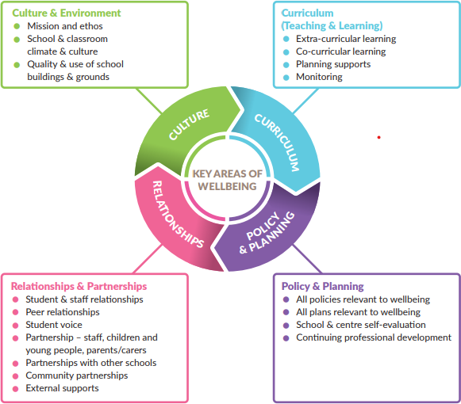

Key Area 1-Culture and Environment
Scoil Mhuire NS aims to cultivate an environment that enhances well being for all who learn, work and visit. Our school environment is one that consciously fosters warm relationships, encourages participation, develops pupil and teacher autonomy and provides clarity of boundaries, rules and positive expectations.

Our school provides a safe, secure and stimulating environment that encourages and supports pupils, staff and members of the whole school community, both in and out of school. We provide a climate in which positive relationships, respect and consideration for others prosper, and where individuals are encouraged to make a vital contribution through their personal skills and qualities.
Our teaching staff, SNA and school secretary strive to create a culture and climate which is accepting and supportive for students, staff and parents. Through nurturing quality relationships within the school we facilitate the wellbeing of students and staff members as well as fostering a shared responsibility for promoting positive wellbeing.

We are proud of our historic building and the spacious setting in which our students can safely learn and be active. The grounds and building are well maintained.

Key Area 2- Curriculum
Wellbeing promotion is central to all areas of teaching and learning in Scoil Mhuire. Teaching and learning is democratic, inclusive, engaging and differentiated. We deliver an integrated curriculum that recognises the richness and uniqueness of the individual through a differentiated approach, and the importance of high quality teaching and learning experiences for all.
Wellbeing promotion is addressed across the curriculum through:
SPHE
Literacy
Aistear
Physical Education
Religious Education
SESE subjects
Arts Education

SPHE: Social, Personal and Health Education is central to pupil development in its broadest sense and is an essential part of a school’s curriculum. The SPHE curriculum in Scoil Mhuire strongly supports the social and emotional wellbeing of our pupils, by placing an emphasis on progressing children’s social and emotional skills, attitudes, behaviour and learning. SPHE encompasses the development of emotional literacy which is the ability to understand emotions, listen to others and empathise. This includes provision of safe, secure and comfortable environments that enable children to share their concerns.

Key characteristics of the SPHE programme delivered in our school:
- It is viewed as a continuous and developmental process
- It comprises of high quality programmes such as Mindful Matters, Stay Safe,
- We acknowledge a shared responsibility between family, school, health professionals and the community
in ensuring children’s wellbeing
- It is based on the needs of the child
- It is effective and consistent in delivery
- It has been developed in an integrated and cross-contextual way
- It engages children in activity based learning (NCCA 1999).

Literacy:

Children that engage with reading are three times more likely to have high levels of mental wellbeing than those who do not (UK National Literacy Trust, 2018).
Scoil Mhuire consistently advocates for the lifelong benefits associated with reading with both students and parents. We strive to foster a love of reading and provide opportunities for a culture of reading to flourish in our school through explicit literacy teaching and the integration of Literacy Lift-Off, Story Time, DEAR time, Library time, , Book Talk, Links to local libraries, Book Week, World Book Day etc into our programme for literacy. We use a range of assessment tools to carefully monitor each child’s progress in reading attainment and to provide additional support where needed.
Aistear: The Early Childhood Curriculum Framework encompasses four themes
- Wellbeing, Identity and Belonging, Communication, Exploring and Thinking.
Much of children’s early learning and development takes place through play and hands-on experiences. Through these, children explore social, physical and imaginary worlds. These experiences help them to manage their feelings, develop as thinkers and language users, develop socially, be creative and imaginative, and lay the foundations for becoming effective communicators and learners. (NCCA, 2009)
Scoil Mhuire has adopted aspects of the Aistear programme into our Junior Room (Junior Infants – 2nd class) programme enabling our youngest students to engage playfully with activities and role play which foster language, communication and social skills development.

Physical Education:

Through physical education the child can experience the joy of physical exertion and the satisfaction of achievement while developing skills and positive attitudes that enhance self-esteem. Physical education provides opportunities to develop desirable personal and social attributes: the concept of fair play, the acceptance of success and failure, and the ability to cooperate in group situations. These opportunities contribute to the understanding and promotion of a healthy life-style. Physical education, as an integral part of the total curriculum, provides vital opportunities for the physical, social, emotional and intellectual development of the child. (Primary School Curriculum)
Scoil Mhuire NS has a vibrant programme for PE which is delivered both by specialist providers and class teachers. We maintain strong links with local sports clubs and organisations such as Mullinahone GAA club, and participate in their in-schools training programmes. We participate in an annual athletics competition and various blitzes in hurling and football as they occur throughout the school year.
We encourage walking, cycling or scooting to school as part of our Green Flag initiative.
All of our pupils participate in swimming lessons every year in the Watershed pool in Kilkenny.

Religious Education:
Scoil Mhuire NS is inclusive of children of all faiths or no faith. Our SPHE programme is taught cross-culturally. General themes around respect, the environment, community welfare etc are taught at whole class level. The school and parish of St. Michael’s church and parent body work together in preparing children for sacraments while children not preparing for sacraments engage in project work suited to their age and interests.

SESE:

Social, environmental and scientific education (SESE) provides opportunities for the child to explore, investigate and develop an understanding of the natural, human, social and cultural dimensions of local and wider environments; to learn and practice a wide range of skills; and to acquire open, critical and responsible attitudes. SESE enables the child to live as an informed and caring member of local, national, European and global communities. (Primary Curriculum)
Scoil Mhuire Kilvemnon adopts an active learning approach to SESE subjects. Our aim is to foster curiosity, develop language and critical thinking skills and to enable children to acquire knowledge and skills through active participation and engaging learning experiences. In addition to the core curriculum Scoil Mhuire NS participates in field trips to places of historical and geographical interest, hosts specialist workshops and “STEAM” weeks (learning in an integrated way through Science, Technology, Engineering, Art and
Mathematics) and promotes an interest in, and respect for the natural environment in a cross-curricular way. We participate in the Science Blast programme, Globe Ireland River study initiative, Green Schools including Green schools workshops both in and out of school.

Arts Education:

Arts education enables the child to explore alternative ways of communicating with others. It encourages ideas that are personal and inventive and makes a vital contribution to the development of a range of intelligences. A purposeful arts education at primary level is life-enhancing and is invaluable in stimulating creative thinking and in promoting capability and adaptability. It emphasises the creative process and so ensures that the child’s work is personal and has quality. Attempts at artistic expression are valued, self- esteem is enhanced, spontaneity and risk- taking are encouraged and difference is celebrated. It is this affirming aspect of the creative arts that makes participation such a positive experience. Arts education is integral to primary education in helping to promote thinking, imagination and sensitivity, and arts activities can be a focus for social and cultural development and enjoyment in school. Arts education encompasses a range of activities in the visual arts, in music, in drama, in dance and in literature. (Primary Curriculum)

Scoil Mhuire NS has a rich tradition of celebrating creativity and fostering the development of the imagination through our Visual Arts, Music and Drama programmes. In addition to curricular provision for Arts subjects Scoil Mhuire NS participates in a range of Arts related experiences which include, but are not limited to:
- Artist in Residence scheme
- Peace Proms
- Music Generation
- Seachtain na Gaeilge
- Class plays and musicals
- Participation in Art and Drama competitions

Key Area 3- Policy and Planning
Scoil Mhuire NS regularly reviews our school policies for staff and pupils to ensure that they are current and in accordance with the school’s vision and ethos. All aspects of the school planning and self-evaluation process in our school incorporate a health and wellbeing dimension.
Wellbeing promotion is addressed in school policies and plans including but not limited to:
- Physical Education
- Religious Education
- SPHE
- RSE
- Code of Behaviour
- Child Safeguarding
- Critical Incidents
- Health and Safety
- Anti-bullying
- Acceptable Use Policy
- Special Educational Needs
- Healthy Eating Policy

Key Area 4- Relationships and Partnerships

Scoil Mhuire continues to develop strong partnerships with parents/guardians and the wider community, which is a central part of the wellbeing process. We effectively engage with appropriate agencies and specialist services to advise, support and contribute to health and wellbeing, teaching and learning.

The following stakeholders meet and collaborate regularly throughout the school year:
- Parents/Guardians
- Teacher groups
- Board of Management
- Parents Association

Two-tiered Approach to Wellbeing Promotion
In Scoil Mhuire NS we adopt a preventative, two-tiered approach to wellbeing promotion, with interventions at both universal whole school and individual targeted levels.

Whole School Approach
Our whole school approach involves all members of the school community engaging in a collaborative process of change and improvement to enhance specific areas of school life which impact on wellbeing.
By adopting a whole school approach, we aim to produce a wide range of educational and social benefits for our pupils, including a culture of positive, pro-social behaviour, a feeling of inclusion, optimum learning experiences, strong social cohesion, increased social capital and ultimately, a strong foundation for mental health and wellbeing.
In Scoil Mhuire NS, we embrace School Support for All as a whole school approach that focuses on promoting wellbeing for all members of the school community. School Support for All is a process of prevention, effective mainstream teaching, early identification and intervention for children who are showing mild or transient signs of difficulty. Students flourish where there is a whole school approach to supporting their growth and wellbeing.
Our Whole School Approach involves:
  - Raising awareness of wellbeing promotion
  - Regular review and development of policies relating to wellbeing such as critical incidents, bullying, child
protection etc
  - Professional development for school staff in wellbeing promotion
Implementing the SPHE curriculum which includes a focus on whole school approaches to wellbeing and health promotion
  - Implementing universal evidence based programmes and interventions
  - Establishing school structures for supporting staff and students including the school support team
  - Establishing mechanisms such as Green Schools Committee to ensure that the voices of children are heard
  - Planning, collaborating and appropriate sharing of information between schools when children are making the transition into primary school or moving into post-primary school
  - Liaising with appropriate external agencies and services eg NEPS psychologists, NCSE etc.

Benefits of a Whole School Approach
Adopting a whole school approach has been found internationally to produce a wide range of educational and social benefits for individual children including:
  - Better learning results for pupils
  - Increased pupil self-esteem
  - Improved behaviour
  - Lowered incidence of bullying
  - Increased inclusion
  - School environment is safer and more secure
  - Improved relationships within the school
  - More involvement of parents/guardians
  - Better use of outside agencies
  - More proactive in promotion of staff wellbeing

Whole School Initiatives that Promote Wellbeing

Scoil Mhuire NS implements a number of programmes and initiatives that support the wellbeing of our pupils, including but not limited to:

  - Aistear: The Early Childhood Curriculum Framework
  - SPHE Curriculum – Mindful Matters, RSE
  - Continuum of Support Model
  - Student Committees: Green School Committee
  - Wellbeing Displays, Art Projects/Team Player Awards, Attendance Display
  - Project based learning
  - Outdoor learning
  - Partnership with the local Sports providers
  - External PE coaches e.g. GAA,
  - Healthy Eating policy
  - Active School Flag
  - Sports Days/Swimming/Athletics
  - Regular class-group assemblies
  - Themed weeks (e.g. Maths Week, Science Week etc)
  - Promoting the Arts – Christmas Concerts, Music Generation, Peace Proms, Artist in Residence/animation, Art Gallery walls established within the school etc
- Golden Time
- Weekly positive affirmation: I will try my best!
- I am special!
- Rewarding good behaviour through Class Dojo points- prize for winner on a Friday
- Class bear- Bring home at the weekends
- Monthly awards- Bí Cinealta
- -Random act of kindness
- Movement breaks- Go noodle, Just dance videos, yoga, Mindful stretching
- Mindful Matters
- Weaving Wellbeing
- Zippys Friends
- Wellbeing Week - May 2025 incorporating Internet Safely

Programmes and External Facilitators
The use of programmes and external facilitators can play a role in supplementing, complementing and supporting a planned comprehensive approach to wellbeing promotion.

Programmes and external facilitators that are accessed in Scoil Mhuire
  - are part of a whole school approach and address an identified need
and are delivered to class groups with the involvement of school staff and the appropriate involvement of parents/guardians
They enhance protective factors which predispose students to positive outcomes in the face of adversity such as: facilitating supportive adult-pupil relationships, strengthening life skills, helping students believe in their capacity to overcome hardship and building a sense of mastery over life circumstances
They adopt a planned implementation process, for example, incorporate needs analysis, use evidence informed programmes and track and evaluate outcomes for students
Programs are implemented and used in our school in a sustained way over a number of years in order to bring about lasting effects and benefits

Individual and Targeted Support
In line with best practice, the Continuum of Support model delivered within our school offers a flexible framework within which we can address all educational needs, including the wellbeing needs of our pupils.

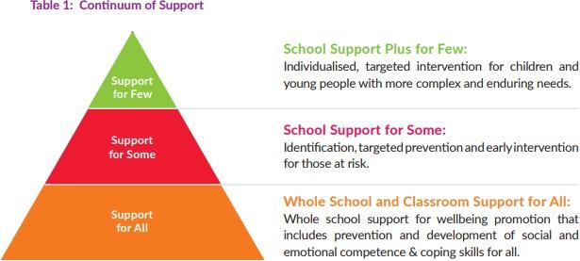

The Continuum of Support recognises that individual children and young people can have different needs at different times. Those at greater risk and with greater needs may require more specific and targeted support, in addition to the support provided to all children and young people in their class-based groups.

Children and young people with additional needs and vulnerable groups are particularly at risk in the area of wellbeing (NCSE, 2014). The National Educational Psychological Service (NEPS) supports schools in promoting the wellbeing and mental health of all children and young people. While supporting all, NEPS prioritises support for those at risk of educational disadvantage and those with special educational needs.

SET in Scoil Mhuire
The Special Education team consists of the Principal, SET, and visiting SET.
The purpose of SET is to provide for students who have a greater need for a higher level of intervention from the school community. The SET regularly reviews the needs of pupils in the school as a whole, under the continuum of support model. Children may be identified through this process that would benefit from further support in school, at home and/or from external agencies.

Objectives and Rationale
Students who experience difficulties in life will find it difficult to have cognitive space for learning. Therefore the rationale of the SET is to strive to care in a genuine way to improve the lives of students and thereby ensure access to the curriculum and learning.
The SETE undertakes the following:

- To liaise with external professionals about the welfare of the child
- To liaise with the parents/ guardians of the child
- To share information in a confidential setting
- To coordinate a targeted response to the needs of a student
- To review and monitor the students with care needs

Referral
All staff members of the school community have a responsibility to be observant of the needs of our students.
The process of referral to SET is as follows:
- The class teacher will refer a student directly to the Special Education Teacher.
- A parent may also raise concerns regarding their child to the class teacher, Principal or Deputy Principal
Once a student is referred:
- the teacher may call home to arrange a meeting with the parents/guardians to discuss concerns
- a classroom support or school support plan may be initiated for the child
- Intervention plans and individual targets are developed
Specific needs may be discussed with external agencies or professionals such as National Educational Psychology Service (NEPs), HSE personnel (Primary Care Team, Assessment of Need Team, Early Intervention Team, School Age Team), TUSLA/National Educational Welfare Board, National Council for Special Education (NCSE)
- Student support plans are reviewed and updated throughout the school year

Documentation and Communication of School Support Plans
Support plans are drafted, shared with parents for consultation, and then finalised before a programme of support commences
- Support plans are uploaded to the drive
Information regarding additional support is included with the handover documents which are shared between teachers at the commencement of each school year
Any confidential information or information which evokes the implementation of the Child Safeguarding Policy are dealt directly by the Designated Liaison Person – DLP, (or Deputy DLP in their absence), and communicated with parents/guardians

External Agencies and Specialist Support Services
Some children will require additional support from specialist support services external to the school. In the event of a child presenting with mental health concerns, which are above and beyond the capacity and ability of the school to provide adequate support, the school may decide upon either of the following courses of action:
Follow existing policies which enable staff to access and refer directly to an external service. In Scoil Mhuire NS, we have established essential relationships with local agencies and have names and contact details readily available for onward referrals.
When deemed necessary, the school team, with the consent and collaboration of parents/ guardians, may recommend a referral to the local General Practitioner (GP) or other appropriate professionals who can advise on referral pathways. For children with mental health difficulties, the referral will likely be made to the local HSE
Psychology Service/Primary Care Team or the Child and Adolescent Mental Health Service (CAMHS).

Indicators of Success
In Scoil Mhuire, we use the Wellbeing Indicators of Success to identify our strengths and targets for improvement, and to actively monitor our progress and outcomes in relation to wellbeing promotion over time. We achieve this by accessing the opinions and views of all stakeholders throughout the process. To date we have sought opinions and suggestions from all stakeholders with regard to indicators of wellbeing specific to us, prioritised on the basis of additional measures that would improve wellbeing for all or for children with specific needs, and reviewed our progress. We are committed to regularly reviewing practices affecting the four key areas of wellbeing using the
Wellbeing Indicators of Success outlined below.
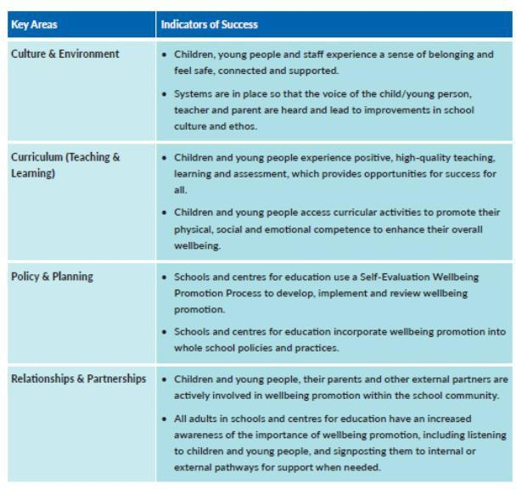
(Table 5 Framework for Practice 2019)
These Indicators of Success in the four key areas of wellbeing are further expanded upon as Statements of Effective Practice (See Appendix A) which provide a set of standards for wellbeing practices across the Continuum of Support at the whole school preventative level (Support for All) and also at the targeted and more individualised levels (Support for Some and Few). These Statements of Effective Practice form the basis of the school’s self-reflective Wellbeing Promotion Process. They enable us to identify strengths and areas to target and therefore plan the next stage in the improvement journey.

Suggested Measures of Success:
- Student attendance
- Successful school completion
- Successful transition of pupils
- Data gathered in school e.g. surveys, interviews, checklists
- Data gathered through consultation with children, parents, teachers and other staff members
- Information from inspectorate reports

School Self-Evaluation Wellbeing Promotion Process

Scoil Mhuire NS is currently developing this policy using the six-step School Self-Evaluation (SSE) process together with the Wellbeing Policy Statement and Framework for Practice.
We have considered our existing provision for wellbeing under each of the four key areas (culture and environment, curriculum, policy and planning, and relationships and partnerships), and identified areas in which new structures could be put in place ?
In devising and implementing the improvement plan, we will refer to the Statements of Effective Practice in key areas and information gathered through consultation with key stakeholders, including staff, pupils and parents/guardians. This information was essential in highlighting positive aspects and strengths in our collective practice and identifying areas for development – the analysis and judgement stage. This analysis will inform actions for wellbeing in a selected area. At an intervention stage, appropriate school interventions and strategies will be generated and agreed. We will incorporate these actions into our School Improvement Plan (SIP). Steps will be put in place to implement the agreed actions. At the monitoring stage, actions will be reviewed on an ongoing basis which will assist us in evaluating impact and tracking our progress in this process of continuous improvement.

Continuous Professional Development

In Scoil Mhuire, we prioritise professional development for school staff in wellbeing promotion for staff and students. Whole-staff professional development for our school includes a focus on the following:
- Identifying and building upon existing good practice in the whole-school implementation of SPHE
- Providing a shared understanding of the wellbeing of children
- Developing an understanding of child development
- Exploring the factors that impact both positively and negatively on wellbeing
Providing opportunities for reflection on the school environment, classroom and whole school practice to establish and maintain healthy patterns of relationships
Raising awareness of the importance of consistency between home and school environments in the implementation of strategies and programmes which promote wellbeing
Considering the implementation of supportive practices in addressing and resolving conflict and other issues arising between children
Raising awareness of the links between risk taking behaviours, bullying and the development of mental health problems
Exploring strategies to develop children’s skills, attitudes and behaviours in dealing with peer pressure, bullying situations or situations involving risk
Equipping teachers to develop their personal capacity and that of the children, for resilience, self-control and coping in a variety of social situations.

Staff Wellbeing
Support for the wellbeing of staff is also an essential element in wellbeing promotion, and crucial to sustaining teacher/staff engagement, enthusiasm and the ability to model resilience. It builds staff capacity to cope with challenges and adapt to change, and creates conditions to support and motivate staff to be proactive and effective members of the school community.Scoil Mhuire Kilvemnon is a safe and supportive environment for the people who work here.
All staff members are supported in maintaining their personal health and wellbeing. We benefit from communally reflecting on our own wellbeing and general attitudes to mental health. All staff members have a role in promoting attitudes and modeling behaviour that is supportive of our collective wellbeing.
  - We strive to create an inclusive, connected and caring setting for permanent, temporary and visiting staff.
  - A collaborative approach to curricular planning, peer-mentoring systems, SET assistance and team teaching help ensure that teachers and SNAs feel supported in their classroom work.
  - School leaders endeavour to assist and advise staff members when required.
  - We come together to organise a variety of inclusive and enjoyable social events throughout the year.
  - All staff members are made aware of support for wellbeing which may be accessed through the Employee Assistance Service (EAS). Spectrum Life was awarded the EAS contract in July 2020.
The service provided is known as ‘Wellbeing Together: Folláine le Chéile’. The EAS provides advice to employees on a range of issues including wellbeing, legal, financial, bereavement, conflict and mediation. It also provides advice and support to school leaders and delivers interventions to help them deal with health and wellbeing issues in the workplace.
Employee Assistance Service: Free-phone confidential helpline 1800 411 057 or text ‘Hi’ to
873690010 - available 24 hours a day, 365 days a year.

Signed: Date:

__________________________________ _____________________
Chairperson

Signed: Date:

___________________________________ _____________________
Principal

